**ADVERSARIAL DEEP STRUCTURED NETS FOR MASS SEGMENTATION FROM MAMMOGRAMS**

**Wentao Zhu Xiang Xiang† Trac D. Tran† Gregory D. Hager† Xiaohui Xie**

**ABSTRACT**

Mass segmentation provides effective morphological features which are important for mass diagnosis. In this work, we propose **a novel end-to-end network for mammographic mass segmentation which employs a fully convolutional network (FCN) to model a potential function, followed by a conditional random field (CRF) to perform structured learning.** Because the mass distribution varies greatly with pixel position, the FCN is combined with a position priori. Further, we employ adversarial training to eliminate over-fitting due to the small sizes of mammogram datasets**. Multi-scale FCN is employed to improve the segmentation performance**. Experimental results on two public datasets, **INbreast** and **DDSMBCRP**, demonstrate that our end-to-end network achieves better performance than state-of-the-art  approaches.

**Dataset**

**INBreast and DDSM-BCRP**

**Work:**

In this work, we propose an end-to-end trained adversarial deep structured network to perform mass segmentation (Fig.1). The proposed network is designed to robustly learn from a small dataset with **poor contrast mammographic images.**

Specifically, **an end-to-end trained FCN with CRF is applied**. Adversarial training is introduced into the network to learn robustly from scarce mammographic images. **we directly optimize pixel-wise labeling loss.** To further explore statistical

property of mass regions, **a spatial priori is integrated into FCN**. We validate the adversarial deep structured network on two public mammographic mass segmentation datasets. The proposed network is demonstrated to outperform other algorithms for mass segmentation consistently.Our main contributions in this work are: **(1) We propose an unified end-to-end training framework integrating FCN+CRF and adversarial training. (2) We employ an end-to-end network to do mass segmentation while previous works require a lot of hand-designed features or multi-stage training. (3) Our model achieves the best results on two most commonly used mammographic mass segmentation datasets.**

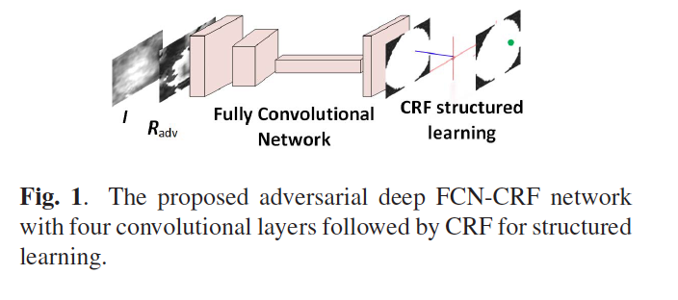

**FCN-CRF NETWORK**



